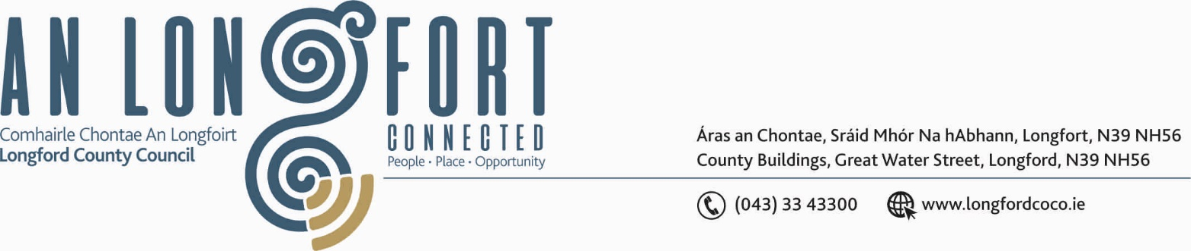

BALLYMAHON MUNICIPAL DISTRICT

Please bring your iPads to all meetings, fully charged, to allow for access to meeting supporting documentation.

8th May 2020.

To: Each Member of Ballymahon Municipal District.

Dear Member,

You are requested to attend Meeting of Ballymahon Municipal District to be held in the Sports Hall, Leisure Centre, Albert Reynolds Peace Park, Longford
on Thursday, 14th May 2020 at 3.00 p.m. to transact business, as set out on the Agenda hereunder.

Yours sincerely,
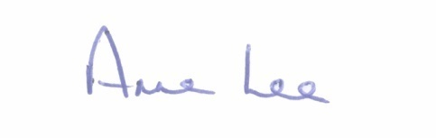

_______________
Anne Lee,
Meetings Administrator.

AGENDA

Prayer before meeting.

1. Confirmation of Minutes of Ballymahon Municipal District Meetings held on the 7th April 2020 - copies enclosed.

2. Matters arising from Minutes.

3. Declaration of Interest by Members.

4. Management Report - enclosed.

5. Consideration of application for funding under the 2020 Community Grant Support Scheme - list enclosed.

6. To consider and approve applications for Special Projects Fund.

7. Consideration of Nominee for the 2020 Cathaoirleach Awards.

8. Fix date for 2020 Ballymahon MD Annual Meeting.

9. Notices of Motions submitted by Councillors, as listed hereunder –

Councillor Gerard Farrell.

“That Longford County Council fixes the drainage issue at Cashel GAA, as a matter of urgency.”

“That Longford County Council Roads Department widen the footpath and erect a barrier at Lanesboro Community College as a matter of urgency and to fix the footpath directly opposite the Community College.”

Councillor Paul Ross

“That the road be widened at the pinch point on the R395 Castlepollard Road, Aghafin, Edgeworthstown in the interest of the safety of children walking to school.”

“That the verge between Stonepark School and St. Catherines Church, Curry be levelled with topsoil and grass resown so that it can be maintained and mown by Stonepark Community Group.”

“That the access to the Greenway at Newcastle Bridge, Ballymahon be altered to improve access for wheelchair users . This can be done by moving the stone slightly at the yellow barrier and putting tarmac at the corner and this would make this walk fully accessible.”

Councillor Mark Casey.

“That this Council provides a footpath from Ardagh Village to Ardagh GAA Pitch.”

“That this Council enters into talks with Bord na Mona for the takeover of
The Green Housing Estate in Lanesborough.”

“That the shared car park between Clonbonny Graveyard and Rathcline GAA Pitch be resurfaced and lined to enable safe parking.”

Councillor Mick Cahill.

“That Longford County Council takes appropriate steps to improve sight lines around the junction at Carrickboy in the interest of road safety as a matter of urgency.”

Councillor Pat O’Toole.

“I call on Longford County Council to give a timeframe as to when the
Dun Aras Housing Estate in Ballymulvey, Ballymahon will be taken in charge.”

“I call on Longford County Council to give a commitment to complete the walkway/cycleway along the banks of the Inny River from Ballymahon Bridge to Newcastle Bridge, to compliment the recent opening of the new Greenway from Newcastle Bridge to the Royal Canal at Kilcurry.”

Councillor Colm Murray.

“I call on Longford County Council to carry out Low Cost Safety Scheme works on the L-1132-0 at Kilcommock Glebe. The tight turn with a blind entrance is proving a significant risk to road users.”

“I call on Longford County Council to carry out surface works on the parking/roadside area’s at Moydow New and Old Cemeteries.”



